**Cyber Patriot Report November 30, 2019**

**NDP Open Division Cumulative Team Score: 450.60**

**Summary Statistics All Open Division Cumulative Team Scores**

**Total Open Division Teams = 2665.**

**Cumulative Open Team Mean Score = 422.6.**

**Cumulative Open Team Median Score = 455.0**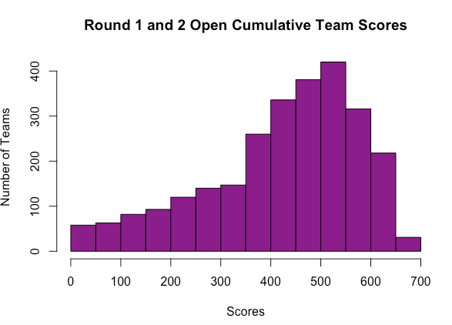

**Summary Statistics All Open Gold Division Cumulative Team Scores**

**Total Open Gold Division Teams = 1078**

**Minimum Median Mean Maximum**

**368.0 453.3 450.3 520.4**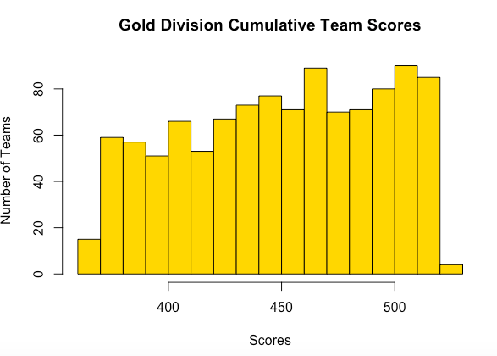

**Summary Statistics All Open Division Maryland Cumulative Team Scores**

**Total Open Division Maryland Teams = 137**

**Minimum Median Mean Maximum**

**0.0 465.4 430.9 657.6**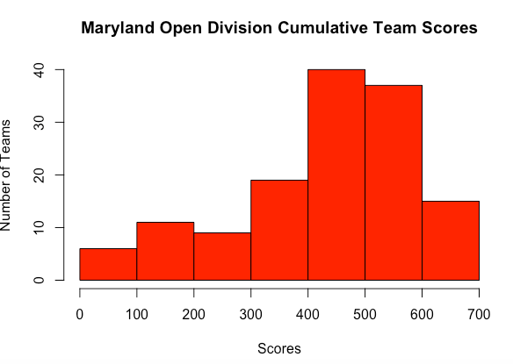

**Summary Statistics All Open Gold Division Maryland Cumulative Team Scores**

**Total Open Gold Division Maryland Teams = 56**

**Minimum Median Mean Maximum**

**368.3 458.7 455.1 520.2**

